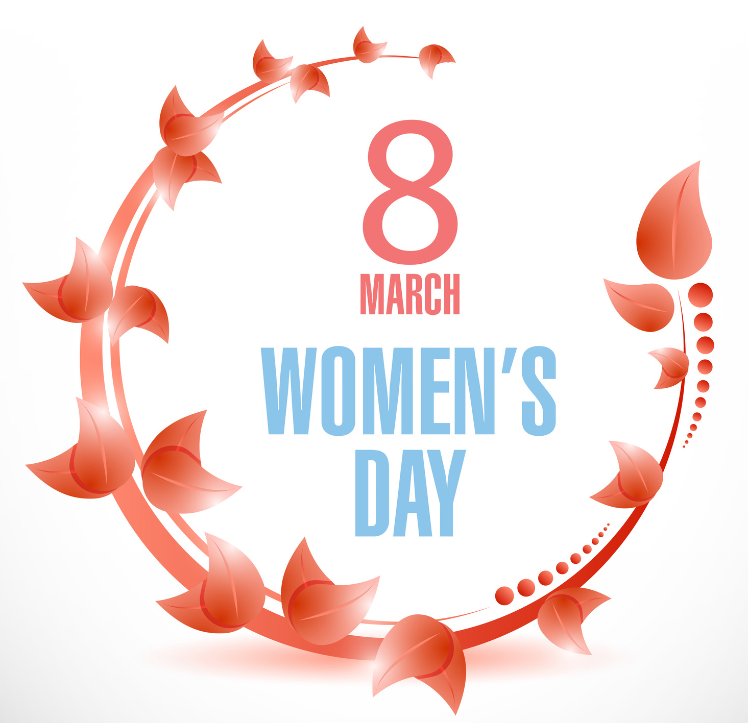
Contact: Deborah Deal, APR
Office: 303-277-9520
Mobile: 407-620-4325
Deborah@ixpowerfoundation.org

STEP IT UP for Women in STEM &
All Women in Colorado

Annual International Women’s Day
March 8, 2017
MERCHANT OFFER FORM

March 8 has been proclaimed International Women’s Day by the Mayor of Golden. Join us in celebrating this important 108-year-old global occasion with Golden, the United Nations, and the rest of the planet, by creating a special discount, add-on, coupon or other offer good March 8 – 12 (Wednesday – Sunday), or for March 8 and the rest of the month. We would also appreciate door prizes.
Your offer or door prize will be announced for free at the March 8 luncheon event, and you have the option of giving us flyers (170 needed) to be handed out at all luncheon attendees. Further, your “special” will be included in a press release to all local media outlets, and listed in The Front Ranger newsletter the entire month of March. Your participation is Free, but please list the special as your “International Women’s Day Special Offer.” Limited to the first 25 business or merchant participants.

To be included in all the promotional opportunities described above, this form with your offer must be received at: Editor@FrontRangePress.com by February 20th. If you want your flyers distributed at the luncheon event, please deliver those to: IX Power, 1440 Brickyard Road, Golden, 80403 by 5 pm on March 6. Questions? Call Deborah Deal at IX Power, 303-277-9520

Type your information directly into the form below, SAVE, and return this document to Editor@FrontRangePress.com
Name of Business:
Location / Address of Business:
What is the specific offer or discount?
Name of person submitting the offer
Telephone number:
Email Address:
Will you provide flyers about your offer at the March 8 lunch event?
Other relevant Information:
Are you going to supply flyers or materials? Need by March 6
Will you supply a door prize?

FACT SHEET

Annual International Women’s Day
March 8, 2017

Admission: For more information and reservations: www.ixpowerfoundation.org.
$30 per person through February 28
$35 per person (if still available) after February 28.

Date: Wednesday, March 8, 2017
Time: 11:30 a.m. – 1:30 pm
Location: Denver West Marriott Hotel
1717 Denver West Dr., Golden, CO 80401
Agenda: Networking, keynote speaker, sponsor speaker, awards, luncheon, door prizes

Keynote Speaker: Dr. Tracy Camp, Colorado School of Mines. More information below.

Other Speakers: Marjorie Sloan, Mayor, City of Golden - confirmed
Libby Szabo, County Commissioner, Jefferson County - confirmed
John Hickenlooper, Governor, State of Colorado – waiting for confirmation

Local 2017 Theme: STEP IT UP for Women in STEM & All Women in Colorado

International 2017
Theme: “Women in the Changing World of Work.” In keeping with the United Nation’s ongoing campaign to boost 90 different countries to STEP IT UP for Gender Equality by the year 2030.

History: This is the second year that International Women’s Day has been celebrated in Jefferson County, Colorado, and the City of Golden will this year proclaim March 8 as Women’s Day. In many countries around the world, this is a day when women are recognized for their achievements without regard to divisions, whether national, ethnic, linguistic, cultural, economic or political. International Women's Day first emerged at the turn of the twentieth century in North America and across Europe and the first time it was observed nationally in the U.S. was in 1909. The Charter of the United Nations, signed in 1945, was the first international agreement to affirm the principle of equality between women and men. The United Nations’ theme for their women’s initiative is “Planet 50-50 by 2030: Step It Up for Gender Equality.”

Sponsors: St. Anthony Hospital – Centura Health
Citywide Banks
City of Golden, Economic Development Commission
The Golden Library, a Jefferson County Public Library facility
IX Power Clean Water, Inc.

Coordination: IX Power Foundation, Inc., a 501(c)(3) based in Golden, and the Jeffco Innovators’ Workshop

STEM Contest: The Golden Library, which has an active STEM girls program, is holding a contest for girls in grades 5 through 8. Colorado School of Mines Female Students (via DECTech)
will be judging the contest. More information below.

Invited Dignitaries: Mayor of Golden, Golden City Council, Jefferson County Commissioners, Colorado’s Governor and First Lady, and more.

Keynote Title: Opportunities and Challenges for Diversifying STEM
Women are significantly underrepresented in several STEM disciplines, and this fact hampers our nation’s technical innovation. Research shows that society needs diverse teams at the table to be most effective. What are the opportunities to bring more women to the table? What are the challenges that exist to get them there? In this talk, we’ll discuss both the opportunities and challenges that exist for diversifying STEM.
About Keynote
Speaker: Dr. Tracy Camp is the Division Director and Professor of Computer Science at Colorado School of Mines. She is passionate about supporting women in STEM disciplines and, thus, created the DECTech programs at Mines (http://tech.mines.edu) in 2012 using best-known practices to encourage girls in STEM. Dr. Camp is currently a member of the Computing Research Association’s Committee on the Status of Women in Computing Research (CRA-W), and served as its Co-Chair from 2011-2014. She is an ACM Fellow, an IEEE Fellow, and an ACM Distinguished Lecturer with research interests in the credibility of ad hoc network simulation studies and the use of wireless sensor networks in geosystems. Dr. Camp shares her life with Max (born in 2000), Emma (born in 2003), her husband (Glen), and two cats.
STEM Girls
Challenge: The STEM Girls Challenge is sponsored and managed by the Golden Library.
      - Eligibility: Girls grades 5-8
      - Participants may work individually or with a group (no more than 4)
      - The contest starts on January 5th and final presentations will take place at the Golden Library on February 22nd. Winners will be honored at the International Women’s Day Luncheon on March 8th.
      - Colorado School of Mines Female Students (via DECTech) will be judging the contest.
      - Each student who submits their creative expression of innovation will receive a certificate of participation.
Creative Detail
- Judges want to see what creations entrants think could help to build a better world or solve an everyday problem. Entries can be related to energy & environment, health & nutrition, or biomedical. Include hypothesis, and a visual of the creation. Visual aids may be a video, tri-fold display, a poster, a model, or anything that best conveys the innovation or solution being described. What will you create? Think big. Think small. Think about how we can build a better world.

For more information about the STEM contest, contact the Golden Library at 303.235.5275. For information about the event contact Deborah Deal at 303-277-9520.

